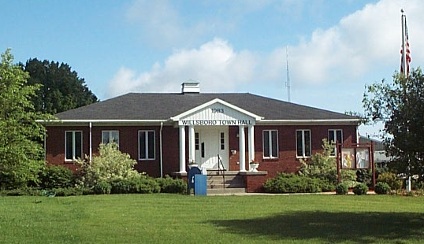
Town of Willsboro
Office of the Town Clerk

REGULAR TOWN BOARD MEETING
DATE: April 11, 2018 AT 6:30 PM
LOCATION: WILLSBORO TOWN HALL

Present: Supervisor, Shaun Gillilland, Councilors: Lane Sayward, Steve Benway, Lorilee Sheehan, Charles Lustig.

Guests: Travis Crowningshield, Justin Drinkwine, Gregg Gordon, Edna Coonrod, Phil Kennedy, Shai Walker, Krissy Leerkes.

The board recited the Pledge of Allegiance.

Supervisor Gillilland awarded Edna Coonrod on her 90th Birthday.

Supervisor, Shaun Gillilland called the meeting to order at 6:30 P.M.

Supervisor Gillilland called for a motion to accept the March 14, 2018 regular town board meeting minutes. Steve Benway moved. Lane Sayward seconded. All in favor and the motion carried.

Reports:
- Supervisor
  - Correspondence: WWTP design approval: on the day before the bids were open we did receive written notification it was approved.
    - NYSPSC information request: Shaun figured based on an hourly rate of $25.00 an hour for 12 hours a week for 30 weeks of employment this will be about $12,000 for the operating cost. This is looking to be about a $167 dollar increase rate to pay for that. Steve asked on updating so that the pressure is better at the end. Shaun stated that he did put in for some updates in these figures. Bob did go around with the Department of health and Mr. Hathaway they figured that this boil water will never go away if the system stays the way that it is. Shaun would like to send out an informational letter as to how everything stands and with the changes. Steve feels we will be between 20 and 25 thousand for a cost to get things going and the way they should be. We currently collect about $7,250.00.
    - Willsboro Water District Annual Report: Department of Health has send this out this will be sent with the next water billing and put on our website.
  - Town:
    - AUD Submitted: this has been submitted. State comptroller came back with a few suggestions.
    - Winter Storm Stella Payment will be about $9,300.00 for this. It is for part A part B will be a little bigger. That is the cleanup piece of the trees and stuff. Travis thought this would be next month on this part.
    - 4 AC land sale paid and closed
    - vets monument contract signed/submitted
    - CEO interviews: we did the interviews we will discuss later.
    - Streambank bids: Low bid is northern snow and dirt. We will discuss later.
    - WWTP Bids: We did this bid opening today. This was two parts one for the build and one on the electrical. We are not ready to accept tonight as we need the engineer to look and make sure it is all there. There was a wide spread in these bids.
    - Septic grants public meeting tentative mid-June update we have about 30 people so far showing interest in these grants.
    - LED update: NYSEG wants to charge us $10,0000 and change them out but NYSEG will still maintain them. NYSEG will get us more info and then we can go from there.
  - County: we are having some issues with North Country Community College. Today they had a ribbon cutting ceremony on the campsite at exit 29 and for Paradox Brewery.
  - Motion to accept Warrant, Supervisor’s Report: Supervisor Gillilland called for a motion to accept the Warrant and Supervisor’s Report. Steve Benway Moved. Lane Sayward Seconded. Roll Call: Benway, Sayward, Sheehan, Lustig, Gillilland. All in favor and the motion carried.
- Town Clerk Report: Supervisor Gillilland called for a resolution to accept the Town Clerks monthly financial report. Lane Sayward moved. Steve Sayward seconded. All in favor and the motion carried.
- DPW Report: Travis got an email from Chris Garrow we will be getting 105,051.64 for chips this year. They put back in the extreme weather money this year. We applied for a grant from soil and water for $7,500.00 to do the lower Buena Vista roads. Travis went and looked at tool boxes. He received a few quotes they are running about $2,000.00 to $2,400.00 for a decent box that will last. Steve Benway moved that we allow Travis to get a decent tool box in that range amount. Lorilee Sheeahan seconded. Roll Call: Benway, Sayward, Sheehan, Lustig Benway. All in favor and the motion carried. We haulded the top soil from Lee Garveys farm and replaced it with sand. Travis has the bill. Supervisor Gillilland called for a resolution to pay the bill for Doug West. Charles Lustig moved. Lane Sayward seconded. Roll Call: Benway, Sayward, Sheehan, Lustig, Gillilland. All in favor and the motion carried. We ended up with about 450 yards from Lee. We will be able to get more from Rodney Moran, but doesn’t need sand we are averaging about $100.00 for the truckload. Steve agrees we need to compensate. We will need a screen plant to screen it. Travis called Doug and he is willing to bring his machine down for $4,000.00, Taylor Rental is 3,200.00, and Sheehan and Sons is $3,000.00 to screen for all the yards on site. Doug figured they would be around 3 weeks Sheehan’s figured 1 week to 1 ½ weeks. Supervisor Gillilland called for a motion for Sheehan’s to screen Charles Lustig moved. Lane Sayward seconded. Roll Call Benway, Sayward, Lustig, Gillilland. Sheehan abstain. In favor and the motion carried. On the 21st at Taylor Rental they will be having an auction. They have a light tower we tried to look at last year but it wasn’t in good shape. Steve said to ask if they will take a purchase order or a letter of credit for x dollars. There is the possibility to get a trailer, light tower and lawn mower Travis said. The board feels $7,500 should be reasonable to pick these items up. Steve Benway moved. Charles Lustig seconded. Roll call: Benway, Sayward, Sheehan, Lustig, Gillilland. All in favor and the motion carried.
- Ambulance District Report: still waiting on the grant for the defibrillators. Ron has everything ready to go back in and they are estimating 9-12 months before that money actually will be received. We had 22 calls for the month on March and 85 calls year to date. Electronic record keeping training will be conducted next month. Shaun asked for a resolution to pay the EMS for their budgeted amount this year. Lane Sayward moved. Charles Lustig second. Roll call: Benway, Sayward, Sheehan, Lustig, Gillilland. All in favor and the motion carried.
- Youth Commission Report: we started spring sports season. They have all the coaches that they need. They would like to have a Facebook page for just youth commission events. We can add them to our g-mail account also so that they don’t need to use personal emails. The booster club is having their 5K this Saturday.
- Parks/Rec./Golf Course Report: Nelly created an email for the summer program and also has created a website. She is doing outstanding. Deanna has also started off great. We are still looking for applications for counselors. We have 4-5 applicants are looking for 6. We did get an application for a cook. Pickle ball has taken off. They have been playing Saturdays and Sundays. Golf Course we have been working over there a lot getting cleaned up. Golf Course hires that Justin recommends this year are Patrick Oliver, William Eisenhardt, Arnold Provost, Otis Gay at minimum wage. Lane Sayward moved to hire those individuals. Charles Lustig seconded. Roll call: Benway, Sayward, Sheehan, Lustig, Gillilland. All in favor and the motion carried. Harold Reynolds would like to volunteer again for his membership. Charles Lustig moved. Lane Sayward seconded. Roll Call: Lustig, Gillilland, Sheehan, Sayward, Benway. All in favor and the motion carried. Shai volunteered to do life guard training if we need it.
Old Business:
- Cemeteries Abandonment Progress & way-ahead: we did pass the resolution for abandonment there has been no movement yet on the transfer of the property. Bridget and Shaun met with Jay Heald from Elizabethtown he gave us a lot of suggestions. We asked for copies of the maps and the plot deeds. We have not gotten the deeds yet. There are none for Gilliland. The maps are here but not up to date. We will need to have this surveyed and make sure that we are good before we start doing burials or anything down there.
- Noblewood contracts amendments: We did get a new contract from the lawyer the alcohol contract was good but we added on the non-alcohol one. Lane Sayward moved to start using the new contract. Lorilee Sheehan seconded. All in favor and the motion carried. These contracts will be effective now.

New Business:
- Streambank Bid results: we have a couple of issues the bids are over budget so we have three options. 1. Is let the money go back. 2. Put the additional money into the project and 3. We would need to see if they could change but we will have issues if we did that. The risk of this job is high. Shaun feels we should reject the bid and we can turn the money back into DEC. Charles Lustig moved to reject all bids and if DEC is willing to give more money to revisit. Steve asked that we close the project out and be done with it. Charles Lustig moved on amended resolution. Steve Benway seconded. Roll Call: Benway, Sayward, Sheehan, Lustig, Gillilland. All in favor and the motion carried.
- WWTP Bid result Shaun proposed that the engineer pick them up and give us an evaluation. Then we can call a special meeting to accept or decline.
- BV Septic EPG: we talked about the county being able to do this work for of us. The first part of this would be to pay for a fly over to establish if they can develop Buena Vista and we will also get the whole point. They could develop the flows for the community septic and the long range plan for storm drainage. The grant will give us about $18 thousand in cost. We may have to pay $5 thousand and wait till the end of the grant to get reimbursed. Supervisor Gillilland called for a resolution to authorize the county to move forward and do a fly over. Lorilee Sheehan moved. Charles Lustig seconded. Roll Call: Benway, Sayward, Sheehan, Lustig, Gillilland. All in favor and the motion carried.
- Out of District water request: Pat Leary has a lot on Bay lane. He would like to hook up as an out of district water customer. He is not a customer of Wilkins and hasn’t been. Lorilee Sheehan moved. Lane Sayward seconded. Steve asked on the public service commission response they asked on customers and fee are we a little behind on this? Shaun said that their fee would be $150.00 plus the current rate per thousand on their assessment. Roll Call: Benway, Sayward, Sheehan, Lustig, Gillilland. All in favor and the motion carried.
Resolutions/Discussion from the Board: Lorillee asked Charlie going through the warrant that we pay $150.00 a month and should they just buy a trailer for the heritage society. Travis said that they have been looking for one they are very hard to come by. There are a few at Taylor Rental. Charlie will bring this up at the meeting and see what they say.

Resolutions/Discussion from the Floor:

Supervisor Gillilland called for a resolution to enter executive session to discuss employment and compensation for town. Steve Benway moved. Lane Sayward seconded. All in favor and the motion carried.
Supervisor Gillilland called for a motion to hire Terry Pulsifer Jr. for code enforcement officer at a rate of $43,000.00 and once training is complete will be compensated at a higher amount. Lane Sayward moved. Lorilee Sheehan seconded. Roll Call: Sheehan, Sayward, Gillilland, Lustig, Benway.

ADJOURNMENT –
Supervisor Gillilland called for a motion to adjourn the meeting. Lorilee Sheehan moved to adjourn. Unanimous second.

Respectfully Submitted,

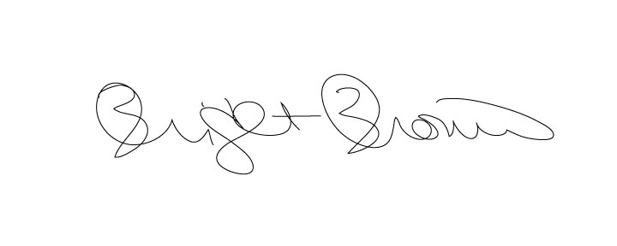

Bridget Brown, Town Clerk

