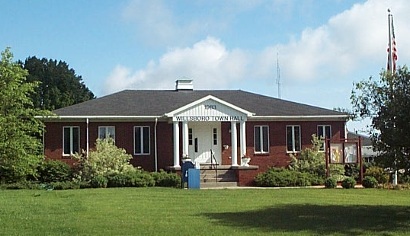
Town of Willsboro
Office of the Town Clerk

REGULAR TOWN BOARD MEETING
DATE: August 8, 2018 AT 6:30 PM
LOCATION: WILLSBORO TOWN HALL

Present: Supervisor, Shaun Gillilland, Councilors: Lane Sayward, Steve Benway, Lorilee Sheehan, Charles Lustig.

Guests: Travis Crowningshield, Justin Drinkwine, Jennifer Jacques, Rebecca Crowningshield Darren Dickerson.

The board recited the Pledge of Allegiance.

Supervisor, Shaun Gillilland called the public hearing to order at 6:30 P.M.

Supervisor Gillilland called for a motion to accept the July 11 2018 regular town board meeting minutes. Lane Sayward moved. Lorilee Sheehan seconded.
Reports:
Supervisor:
- Correspondence: Water Meters: Shaun received a letter in regards to getting water meters from seasonal residents as they don’t use a lot of water. We are looking into them. Nature Conservancy Noblewood Beach: We received a letter on the beach we will discuss this later on in the meeting.
- Town: Water Emergency: This is still in effect. Use is down but we still need to be cautious. WWTP: the work is continuing and we are on the bypass. The water coming out is cleaner than before. The tanks have been cleaned out, and there doing the piping work. There was a problem with a certification and the contractor but we have that resolved.
- Dock and Coal Lane abandoned dwelling we have had multiple complaints on this.
- Grant Program:
  - Vet Memorial: we had the kick off meeting and met with the legion waiting on contract review with GPI.
  - Hathaway Park: Topsoil procured and on site. The next step will be to start clearing.
  - Canoe/ Kayak launch: reviewed by soil and water general permit. Asking county engineer to do schematic for bid.
  - Adsit cabin: discussions to develop scope of work from community resources.
  - Paine Gatehouse: waiting on work proposal from Premises Architecture. Shaun will get that to next month’s meeting.
  - Water Meters: Working with Cedarwood on going forward. We can’t find anyone to go in and install them so we will have to go another route. Then we will have to go with bid for sewer district
  - Septic Replacement: we are accepting applications. Some of the rules have changed.
- 2019 Budget
- 2% to be under CAP with carryover allows approx. $50K increase
- 1.5% increase in Union pay
- Early est. increases in insurance: 8.9% high deductible. 1.5% platinum, 13% in retiree
- Schedule
  - 20 September budget requests submitted to Supervisor
  - 1 October Tentative Budget filed with Town Clerk
  - 10 October Tentative budget submitted to Town Board for acceptance as Preliminary budget
  - If required introduce Local Law to override tax cap
  - 7 November Public Hearing on Preliminary Budget if required public hearing to override tax cap
  - 14 November Final Adoption 2019 Budget

Supervisor Gillilland called for a motion to accept the Warrant and Supervisor’s Report Charles Lustig moved. Lane seconded. Roll Call: Benway, Sayward, Sheehan, Lustig, Gillilland. All in favor and the motion carried.

Town Clerk Report: Nothing new to report. Lane Sayward moved to approve the monthly Town Clerk report. Charles Lustig seconded. All in favor and the motion carried.

DPW Report: They will be paving on the Reber Road on the 4th of September. They have been replacing the rusted out culverts. They have the rocks for Cedar Lane. We are just waiting for Cederwood to get in touch with Travis to get this project started. Bob said sewer plant is working and going good. We interviewed for the new hire. We recommend Michael Phinney under the condition that he gets his license. He was supposed to go today for the test but they had to cancel. DMV has rescheduled for Friday. Travis asked for a motion to hire Michael Phinney as HEO and hire at that rate of pay contingent he gets his CDL. Charles Lustig moved. Steve Benway seconded. Roll Call: Benway, Sayward, Lustig, Gillilland. All in favor and the motion carried. ABSTAIN: Lorilee Sheehan.

Ambulance District Report: July they had 35 calls and total year to date is 216. We did receive mutual aid twice in the last month. We had two calls back to back during the day. We have a new medical director. We have also accepted two new members this month. They had an EMT volunteer for the Iron man and they visited the summer camp. Shaun said at the County they are having a meeting and the state has awarded EMS 6 ½ million dollars to get the county wide EMS system up and rolling. This will be a set up over the next 5 years.

Youth Commission Report: Lorilee said that Krissy did text her they are still in need of some more coaches for soccer season.

Parks/ Rec. Golf Course: Summer program did great numbers are still staying high. Nelly has done an excellent job of getting lots of local visitors in. We will not have a beach after camp since all our life guards are college students. The tent sites that are there are being used a lot this year. Golf Course: We had to replace the control boxes at the golf course. The relay in the electrical box is bad we are hoping that will fix it. Charlie said that he went to camp and the numbers are staying nice and wanted to commend the program this year.

Old Business
- CO project reassignment of personnel. Supervisor Gillilland called for a resolution to assign Mark Dubrey, George Shepler, and Thomas Campbell and remove Mona Lapage, Vern Chamberland Dennis Bonville. Charles Lustig moved. Lane Sayward seconded. All in favor and the motion carried.
- Authorization for $1.00 hour stipend to DPW personnel working in WBWC. This will only be for when they are working down there on this project. Travis is working on getting the hours. Supervisor Gillilland called for a resolution to pay these guys $1.00 an hour when working down there. Lorilee Sheehan moved. Charles Lustig seconded. Roll Call: Benway, Sayward, Sheehan, Lustig, Gillilland. All in favor and the motion carried.
- Arbitration revised invoice we are responsible to have to pay for $900.00. Supervisor Gillilland called for a resolution to pay the $900.00. Charles Lustig moved we pay. Lorilee Sheehan seconded. Steve said he thinks we should have some sort of verbiage because our contract says losers have to pay and he wants to make sure that we aren’t setting a precedent. Roll Call: Benway, Sayward, Sheehan, Lustig, Gillilland. All in favor and the motion carried.

New Business
- Noblewood Beach Easement Enforcement remainder summer 2018. We have a letter from Nature Conservancy stating they would like patrolling of the beach. Peter Paine’s family was up and on Saturday there was a lot of people and boats on the beach. The complaint was that there was loud noise, grills and drinking on the beach. Shaun received the call on Monday after the fact. Shaun said we don’t have a noise ordinance. The grills and alcohol are not allowed. Shaun asked if the DPW guys would be interested in patrolling this on the weekends and they are not. Shaun asked other town employees and no one was interested. Jennifer Jacques asked if anyone has ever been to the end. It could be very dangerous. A lot of these people are from Vermont and Canada. Shaun said he can call the Sheriff’s department and ask them to patrol however they will be looking to ticket a lot higher than warnings. Unfortunately this is going to be an ongoing issue. We do have responsibly to enforce the easement rules. Steve asked if any of the colleges do law enforcement internship. Travis said you are going to want someone trained to deal with this. Lorilee said that the locals were doing a great time enforcing this, but they weren’t there. Shaun has another meeting with the Paine’s on Monday. This is something that we will need to get figured out. Charlie asked if we have signs and yes we do.
- GIS project and equipment authorization: This is to get everything on the county system. They have bought a lot of licenses and we can go under them. Travis and Shaun sat down with County DPW and the engineer. If we bought a tablet and a high quality antenna we could train a few guys from DPW to do mapping. It will piggy back onto the county. This will allow us to find valves quickly in the winter. Shaun asked for authorization to get on the system so that we can get the data put in and get the guys trained. We have a nice balance in reserve Shaun said we can use that to purchase the system. Charles lustig moved to purchase GIS. Steve Benway seconded. Roll Call: Benway, Sayward, Sheehan, Lustig, Gillilland. All in favor and the motion carried.

Motion Comments from the board: NONE

Motions comments from the public:

Supervisor Gillilland called for a resolution to enter executive session with invitation of Travis Crowningshield and Bridget Brown to discuss employee compensation. Lane Sayward moved. Charles Lustig seconded. All in favor and the motion carried.

Supervisor Gillilland called for a resolution to exit executive session no decisions were made. Steve Benway moved to exit. Charles Lustig seconded. All in favor and the motion carried. Supervisor Gillilland briefed on additional duties to Bob and Nate they discussed compensating $1.00 an hour increase. Supervisor Gillilland called for a resolution to pay Bob Murphy and Nathan Jacques $1.00 an hour pay increase contingent on discussion with Union and Lawyer. Charles Lustig moved. Lorilee Sheehan seconded. Roll Call: Benway, Sayward, Sheehan, Lustig, Gillilland. All in favor and the motion carried.

Darren Dickerson wanted to thank Travis and the Highway guys for moving some of the banners out to Reber. It was a request that was put in for the following year but hey took on the task and made it happen this year. It was greatly appreciated.

ADJOURNMENT –
Supervisor Gillilland called for a motion to adjourn the meeting. Lorilee Sheehan moved to adjourn. Unanimous second.

Respectfully Submitted,

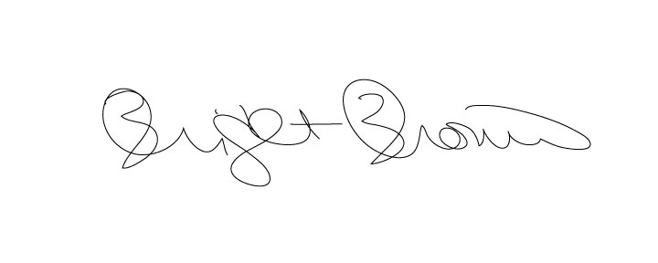

Bridget Brown, Town Clerk

